Chapter 2, Problem 14.

Given the circuit in Fig. 2.78, use KVL to find the branch voltages V₁ to V₄.

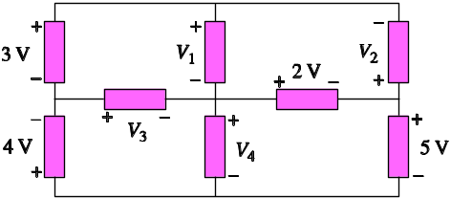

Figure 2.78
For Prob. 2.14.

